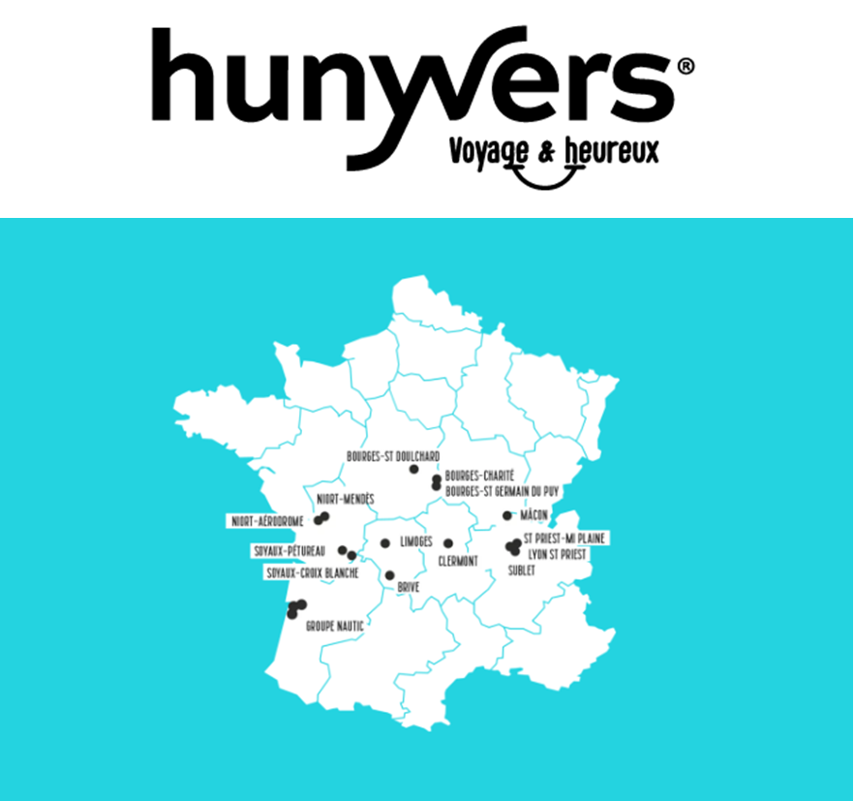

**Les 16 concessions du groupe :**

[Hunyvers Niort Mendès](https://www.hunyvers.com/les-concessions/)[Hunyvers Mâcon](https://www.hunyvers.com/les-concessions/)

[Hunyvers Bourges Charité](https://www.hunyvers.com/les-concessions/)[Hunyvers Bourges St Germain](https://www.hunyvers.com/les-concessions/)

[Hunyvers Bourges St Doulchard](https://www.hunyvers.com/les-concessions/)[Hunyvers Soyaux Croix Blanche](https://www.hunyvers.com/les-concessions/)

[Hunyvers Soyaux Pétureau](https://www.hunyvers.com/les-concessions/)[Hunyvers Lyon St Priest](https://www.hunyvers.com/les-concessions/)

[Hunyvers St Priest  Mi Plaine](https://www.hunyvers.com/les-concessions/)[Hunyvers Brive](https://www.hunyvers.com/les-concessions/)

[Hunyvers Clermont](https://www.hunyvers.com/les-concessions/)[Hunyvers Limoges](https://www.hunyvers.com/les-concessions/)

[Hunyvers Niort Aérodrome](https://www.hunyvers.com/les-concessions/)[Hunyvers Saint Priest](https://www.hunyvers.com/les-concessions/)

[Hunyvers Sublet](https://www.hunyvers.com/les-concessions/) **Hunyvers Chinon**